CT Physical Fitness Standards
2015-2016
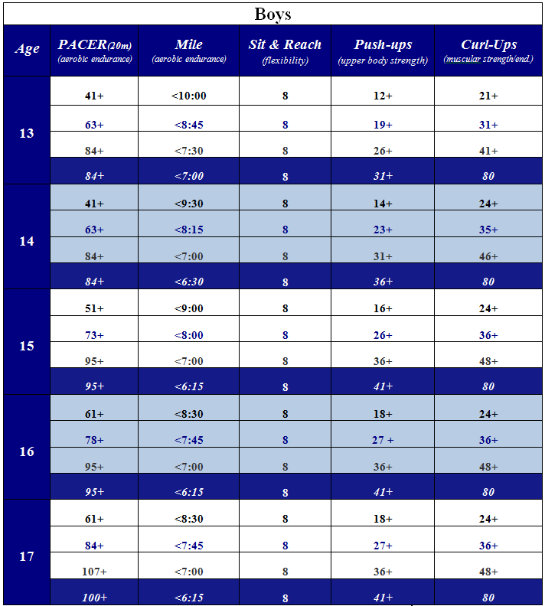
Black = Health Fitness Standard
Blue = Staples Fitness Standard
Platinum = CT High Fitness Performance - Challenge Standard
White = SHS High Fitness Challenge Standard
CT Physical Fitness Standards
2015-2016
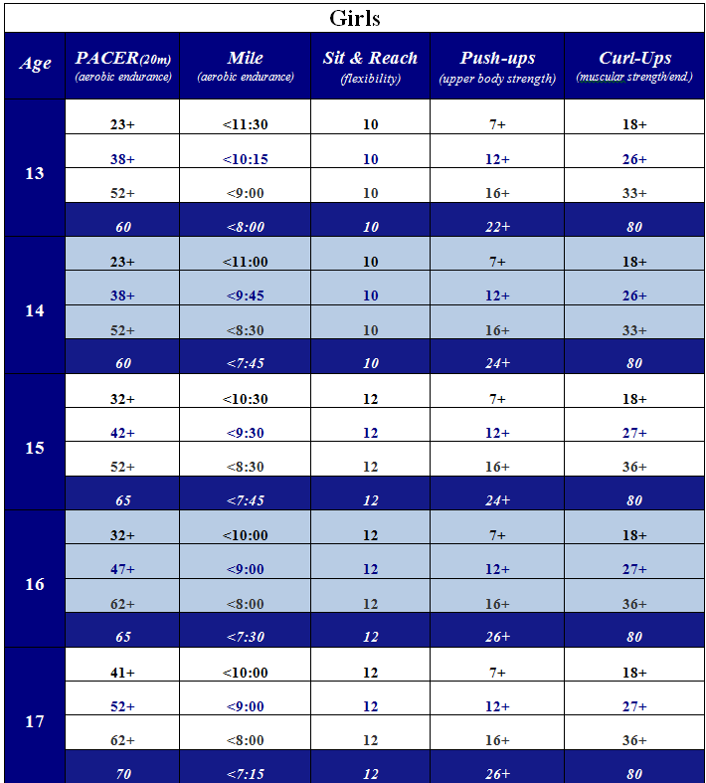
Black = Health Fitness Standard
Blue = Staples Fitness Standard
Platinum = CT High Fitness Performance - Challenge Standard
White = SHS High Fitness Challenge Standard

