NASPE National Standards
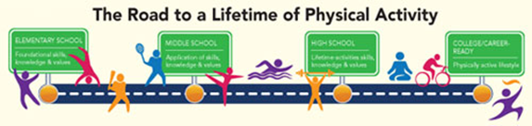
Physical Education
The goal of Physical Education is to develop physically literate individuals who have the knowledge, skills and confidence to enjoy a lifetime of healthful physical activity.

To pursue a lifetime of healthful physical activity, a physically literate individual:
- Has learned the skills necessary to participate in a variety of physical activities.
- Knows the implications of and the benefits from involvement in various types of
physical activities.
- Participates regularly in physical activity.
- Is physically fit.
- Values physical activity and its contributions to a healthful lifestyle.

Standard 1 - The physically literate individual demonstrates competency in a variety of motor skills and movement patterns.

Standard 2 - The physically literate individual applies knowledge of concepts, principles, strategies and tactics related to movement and performance.

Standard 3 - The physically literate individual demonstrates the knowledge and skills to achieve and maintain a health-enhancing level of physical activity and fitness.

Standard 4 - The physically literate individual exhibits responsible personal and social behavior that respects self and others.

Standard 5 - The physically literate individual recognizes the value of physical activity for health, enjoyment, challenge, self-expression and/or social interaction.

Perform. Apply. Maintain. Respect. Value.

